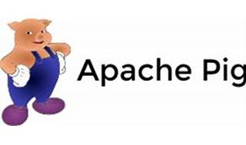



Explore

Certainly! **Apache Pig** is a high-level platform for analyzing large data sets. [It provides a simple query language called **Pig Latin**, which allows you to express data transformations such as merging data sets, filtering them, and applying functions to records or groups of records1](https://pig.apache.org/)[2](https://bing.com/search?q=what+is+apache+pig).

Here are **five free reference links** where you can learn more about Apache Pig:

1. [**GeeksforGeeks**](https://www.geeksforgeeks.org/introduction-to-apache-pig/): This tutorial provides an introduction to Apache Pig, explaining its features, components, and use cases[3](https://www.geeksforgeeks.org/introduction-to-apache-pig/).
2. [**Wikipedia**](https://en.wikipedia.org/wiki/Apache_Pig): The Wikipedia page offers concise information about Apache Pig, including its purpose and the language it uses (Pig Latin)[4](https://en.wikipedia.org/wiki/Apache_Pig).
3. [**Official Apache Pig Documentation**](https://pig.apache.org/about.html): Explore the official documentation to dive deeper into Pig’s features, Pig Latin, and practical examples[5](https://pig.apache.org/about.html).
4. [**TutorialsPoint**](https://www.tutorialspoint.com/apache_pig/index.htm): This tutorial covers Pig basics, execution modes, and practical examples. [It’s great for beginners who want to perform MapReduce operations without complex Java coding](https://pig.apache.org/)[6](https://www.tutorialspoint.com/apache_pig/index.htm).
5. [**JavaTpoint**](https://www.javatpoint.com/pig): Another resource with examples, this tutorial walks you through Pig, Hadoop, and related concepts[7](https://www.javatpoint.com/pig).

Happy learning! 🐷📚